Voting Systems Exploration

1. Vote for your favorite candy. (write in on sticky notes; if less than 5 participants, ask each to channel a close friend)
   1. Arrange ballots on board or table; analyze vote
   2. Does the group have a preferred candy?
   3. Issues? Improvements?
2. Narrow the choices to 4 (pre-selected, based on grocery store availability)
   1. Submit ranked ballots (sticky notes again or index cards)
   2. Clear winner?
3. Watch video (stop as needed; will go through each after): [Voting Systems Video](https://www.youtube.com/watch?v=HoAnYQZrNrQ)
   1. Details: 55 (carefully chosen) ranked ballots (2:20)

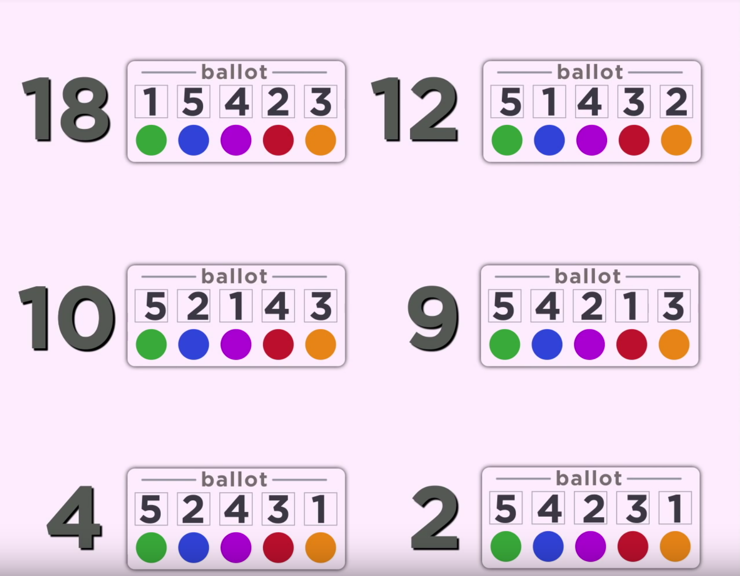

* 1. Plurality (3:00): winner is the candidate who receives the most #1 rankings; NOT necessarily a majority (Green wins; 33% of #1 votes)
  2. Two-round runoff (3:45): (Blue wins)
     1. if one candidate DOES have a majority of #1 votes, they win
     2. (4:25) if not, top two candidates run again; with ranked ballots, can simulate 2nd round
  3. Instant runoff (4:45): eliminate the lowest ranked candidate in each round and re-vote; ranked ballots can simulate later rounds; who is their “next #1”? (5:10; Purple wins)
  4. Borda count (5:40): assign point values to rankings and consider totals (Red wins)
  5. Condorcet criterion (7:20): consider all possible pairings (5 colors, 10 pairs); candidate who wins the most head-to-head pairings wins (each pairing counts all 55 votes; Orange wins)

1. Introduce “majority fair” property: If one candidate is the most preferred by more than half of voters, then that candidate should be the group’s most preferred candidate (clear winner).
2. Apply each system to the candy ballots (essentially #2 from the worksheet)
3. Real-life applications (#3 and 4 from the worksheet)
   1. “Honest” if actually voting preference
   2. “Strategic” if voting to have your candidate win
   3. Develop idea of Electoral College (do we want to go to US politics??)
4. Introduce Arrow’s Impossibility Theorem (there is a second video, but I don’t think its as good to watch as a group)
   1. Two properties:
      1. Unanimity: If everyone ranks A higher than B, then the system should rank A higher than B.
      2. Independence of Irrelevant Alternatives: candidates should maintain relative rankings between any pair (e.g., if one candidate is removed, that should not change the relative rankings of remaining candidates)
   2. Theorem states that NO ranked system has unanimity, independence of irrelevant alternatives, and is non-dictatorial. (Proof shows that if system has the two properties, there must be a dictator.)
5. Eat the candy. ☺